WebGIS 2.0 Platform for Earthquakes Visualization

Dr. Rostislav Netek¹
MSc. Tomas Burian¹
¹ Dept. of Geoinformatics, Palacky University Olomouc, Czech Republic

ABSTRACT
The paper describes the deployment of an open-source Crismapp platform. It is a WebGIS 2.0-based solution designed primarily for crisis management purposes. As part of a cooperation with the University of Bergen, Crismapp was implemented for the purposes of monitoring the earthquake in the Norwegian region within the European-wide observation network EPOS. HTML5-based application reflects the WebGIS 2.0 principle and uses as much as possible open tools: the Leaflet map library and GeoJSON data format. Besides the visualization client, it has a complete administration (back-end). The paper introduces students to the priorities of the Crismapp platform, including a demonstration of its flexibility in a particular deployment for viewing the earthquake in Norway. Moreover, paper handles with the term “WebGIS 2.0“. From a stylistic point of view, the WebGIS 2.0 concept combines two separate ideas, WebGIS and Web 2.0. From a technological point of view this concept combines the latest methods in the GIT context and, in principle, is based on the methods of service-oriented architecture and the Internet as a platform, and Cloud Computing.
Keywords: crisis mapping, Crismapp, earthquakes, WebGIS 2.0

INTRODUCTION
Data are one of the most crucial fragments of crisis management nowadays. Suitable solutions providing fast, correct and user-friendly data interpretation gives strong tools for both preparation and evaluation of natural hazard including earthquakes. According to [3] “European Earth scientists have played a major role in the study of plate tectonics during the past 50 years making great advances, opening new horizons and creating a framework to explain the first order plate dynamics and to model deformation processes”. European Plate Observing System (EPOS) provides technical infrastructure for observation and monitor all kind of seismic, volcanic, tectonic or any other dynamic data especially around Scandinavia. On the other hand, Crismapp platform is an universal web map platform suitable for these kind of data. The combination of EPOS data with flexible web-based map platform brings together an unique possibility to visualization earthquakes data via web platform in user-friendly way, and provide tools and habits of professional geographical information systems in web browser for both scientists and common user by following WebGIS 2.0 concept. The article describes concept of fast, flexible and user-friendly platform for earthquakes visualization.

WEBGIS 2.0 CONCEPT
Based on the crisis of typical robust map server widely used by previous generation, described by Nétek [6] or Timoney [10], both technical and user´s purposes of web map solutions has undergone evolution within past years. Authors operate with the term “WebGIS 2.0“ as a personal solution [5]. In the relevant form, the alternatives for the term WebGIS 2.0 mentions in its work Pinde and Jiuilin [7] or Tilio [9], which used the suffix 2.0 for WebGIS for the first time in 2009. From a stylistic point of view, the WebGIS 2.0 concept combines two separate ideas, WebGIS and Web 2.0. From a technological point of view this concept combines the latest methods in the GIT context and, in principle, is based on the methods of service-oriented architecture and the Internet as a platform, Rich Internet Application, and Cloud Computing [6].

WebGIS 2.0 = Web 2.0 + WebGIS = (SOA + RIA + cloud + …) + (web platform + GIS/GIT)
A characteristic implementation of the WebGIS 2.0 concept could be considered as state-of-the-arts cloud GIS solutions, for example ArcGIS Online, CARTO, MapBox. There is a with a strong user-oriented solution and an emphasis on user intuitiveness. Compared to a variety of other visualization tools, it offers advanced analytical tools [8].

CRISMAPP PLATFORM
Based on the cooperation with the Olomouc Region Fire Department, an idea of an flexible web map platform has been developed at the Department of Geoinformatics, Palacky University Olomouc, Czech Republic. It is called Crismapp, as an acronym of Crisis Map Application. It fully follows WebGIS 2.0 concept – flexible, portable, and modular solution for edit and visualization purposes. According to [6] it was “designed and developed to support crisis management in response to the original model, which was an ineffective way of sharing internal spatial data sources, especially the lengthy process of data updating. Principally it combines a number of the general requirements of rescue systems aiming to geospatially support rescue services during disasters such as floods, fires, and anthropogenic accidents”. This article focuses on specific deployment for earthquakes only but generally Crismapp is suitable for any kinds of crisis management topics, such as traffic accidents, fires, flood etc. A publicly accessible pilot version of Crismapp is available at the URL: http://crismapp.eu/ [1]. Currently, a new stage of the Crismapp project is under the development process. Based on users´ requirements and comments new features will be added (enhanced symbology, advanced searching, simplified admin). It is planned to release Crismapp as full open source projects - under the open license and share source code via Github. From technological point of view the Crismapp is developed under the HTML5, styling is provided by CSS3. Mapping functionality is handled by the JavaScript platform Leaflet. Dynamic content is generated by the PHP scripting language. All the parameters that can be set in administration are stored in a MySQL relational database [6].

EPOS
European Plate Observing System (EPOS) [3] project is a pan-European initiative to create data collection and monitoring infrastructure for earthquakes, volcanic activity and tectonics and to be used in both crisis management and scientific research at European, national and local levels. Due to the top experience of Scandinavian research institutions with monitoring and evaluation of seismological, geodetic, geological and geophysical data, Norwegian scientific and research institutions are predominantly involved in the development phase. Its management is then entrusted to an institution that belongs in its field to the world's top - Department of Earth Sciences at the University of Bergen. The EPOS was launched in 2008, with a preparatory part last year. In the years 2016-2020, the implementation part is in progress. WP6 and WP7 working groups at this week's University of Bergen discuss the possibility of data harmonization between individual providers and users, technical metadata specification, and first graphical interface design (GUI). According to [3] EPOS “is a research infrastructure and e-science for data and observatories on earthquakes, volcanoes, surface dynamics and tectonics. EPOS has been submitted for the update of the ESFRI Road Map in November 2007 and it has been evaluated during 2008 and was included in the ESFRI 2008 Road Map on December 2008”.
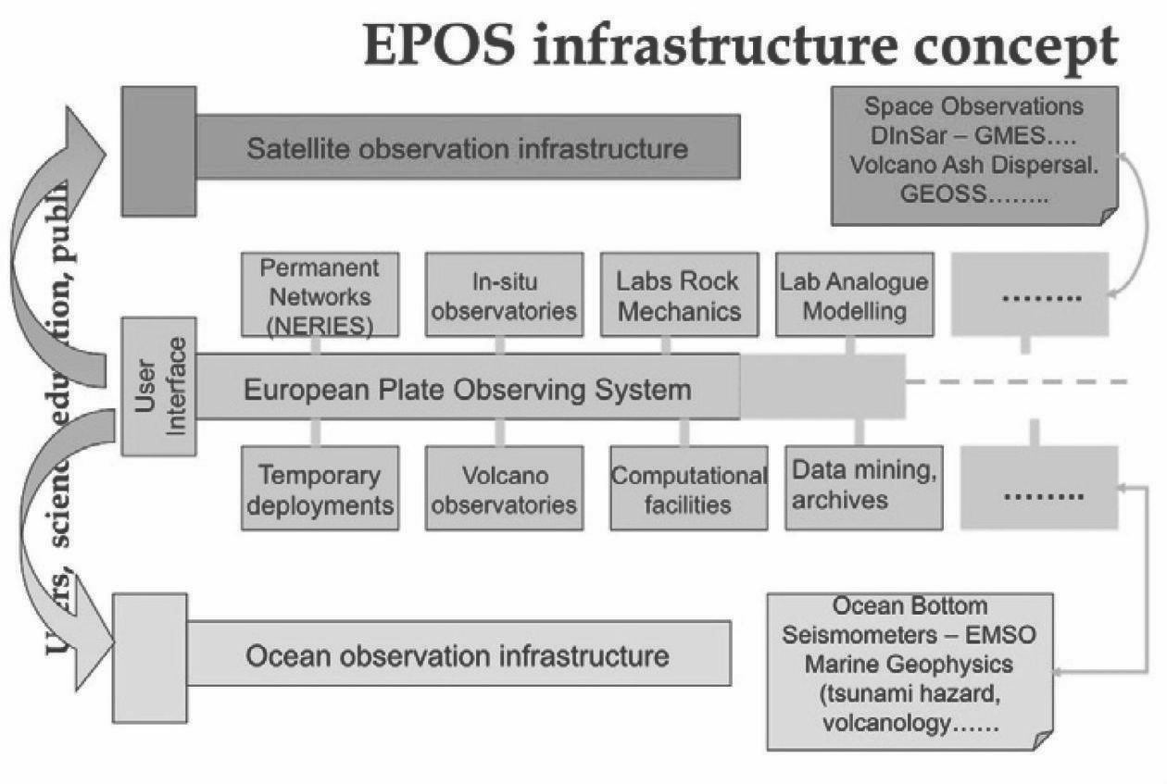
Figure 1. European Plate Observing System (EPOS) infrastructure; source [3]

Earthquakes Visualization VIA CRISMAPP
Based on the cooperation between Palacký University Olomouc, Czech Republic and University of Bergen, Norway an idea of earthquakes visualization client was born. University of Bergen involved in EPOS project provides direct access to earthquakes data, Palacký University brings Crismapp concept a support to the cooperation. An pilot study focused on earthquakes was implemented. In total around 60 000 of real earthquake records is visualisated. Spatial extend of visualisated data is limited to Scandinavia. An extra features and extra data was implemented into Crismapp for this study:
- Tile layers Norkart (Norway Cartographic Office) as basemap layers
- WMS layers from Statkart (Statens kartverk = Norwegian mapping authority) provider as operation layers
- Diving and symbology earthquakes data by magnitude into four classes (0 –1.0, 1.1 – 2.0, 2.1 – 4.0, 4.1– 8.0)
- Pop-up info windows with several attribute data (ID, name, magnitude, data, row)

The concept has a minimalist and clear design due to intuitive control by both mouse and touch screen. The most commonly used tools (search, scale, return to the start, full screen mode, locate the current position, print, measure lines and surfaces, search) are located at the right edge of the screen. At the left edge is the main menu (layer list of predefined points of interest, help), which can be minimized. The layout with vertical side panels is according to the “F rule” convention [4] - the panel at the left edge provides an overview of standard layers with a legend (Table of Contents). Finally, the design of the interface allows easy adaptation to mobile devices without fundamental changes to the map composition. Most of the screen displays the map and functionality is limited to the necessary elements only. This is the fundamental principle of user centered design [4] and leads to more effective ways of navigating and working with the map. Tabs at the left edge contain basic tabs:
- Layers – table of contents with interactive legend and description.
- POI - list of predefined points of interests
- Help

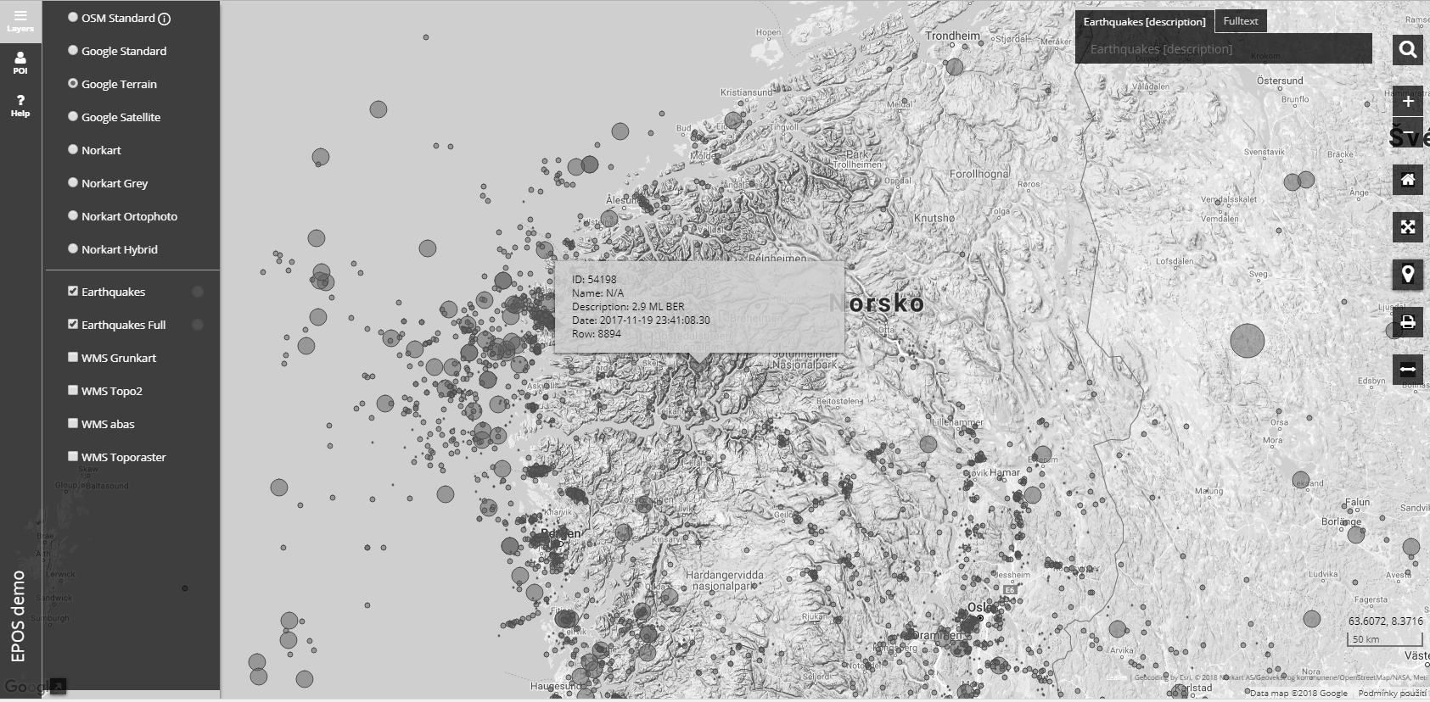
Figure 2. Interface of Crismapp with earthquakes data from EPOS
One of the benefits of selecting the Leaflet JavaScript library was to support asynchronous data loading. It eliminates the time lag in redrawing the map field while a user works with the map. The Crismapp solution combines two data accesses:
- Raw GeoJSON, which is natively supported as a default vector data format.
- Web services (OGC standards: WMS, WMTS, WFS, WFS-T) and Esri Dynamic Layer (REST). Shapefile, as a totally inappropriate format for web solutions, has been disabled.

Compared to closed commercial formats (e.g. Shapefile), GeoJSON is an open flexible format allowing spatial and non-spatial information that can be edited in any conventional GIS programs as well as ordinary text editor to be stored. The major advantage of GeoJSON is the option to load it from any Web server both remotely and locally, which allows work to be done offline. There is no need to publish spatial data through complicated map servers. Public web storage or secure individual server hosting could be used. The pilot application uses storage of GeoJSON into a Github/Gist repository due to versioning. The comparison of changes among document versions (temporal variability) and the possibility of an eventual return to existing versions in the case of errors is very beneficial but purely optional. As Crismapp is an open ready-to-GeoJSON platform only one step of data preprocessing is needed. Data from EPOS sensor network provided as CSV file are transformed into GeoJSON features. Only selected attributes (ID, name, magnitude, data, row) are transformed, saved and visualized due to minimize size transferred data as well as improve performance of map application [2].
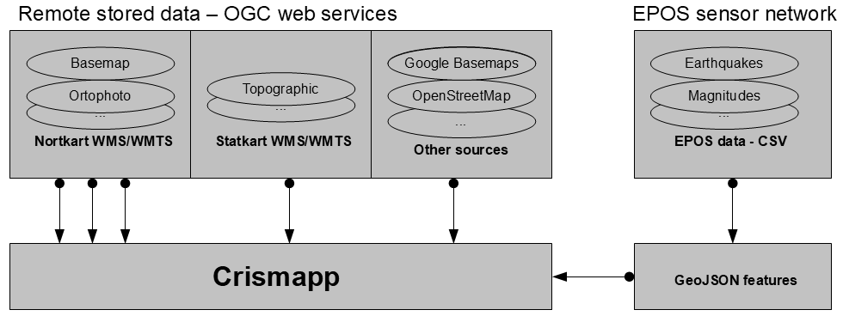
Figure 3. Crismapp combines public OGC web services with GeoJSON

CONCLUSION
Correctly interpreted data in crisis management, especially prompt evaluation of critical situations, may play a crucial role in terms of saving lives, issuing evacuation orders, or rescuing assets XX. The paper gives an overview on the purpose and the development of map platform for earthquakes visualization based on the Crismapp platform. The Crismapp is an open platform developed at the Department of Geoinformatics, Palacký University Olomouc, Czech Republic for crisis management purposes. A publicly accessible pilot version is available at the URL: http://crismapp.eu/. This case study combines data from worldwide sensor network EPOS, especially it is focused on earthquakes spots. Both spatial and attribute data are server via GeoJSON format. The described application based on the Crismapp concept presents a solution built on the latest geospatial technologies for crisis management, including visualization both spatial and attribute earthquakes data from European Plate Observing System (EPOS) network.
ACKNOWLEDGEMENTS
This paper was created within the project "Innovative evaluation methods and advanced analysis of spatially based systems" (IGA_PrF_2018_028) with the support of Internal Grant Agency of Palacky University Olomouc.

REFERENCES

[1] Crismapp. 2018. URL: http://crismapp.eu/ (14.5.2018)
[2] Dobesova Z., Vavra A., Netek R. Cartographic aspects of creation of plans for botanical garden and conservatories. 2013. Conference Proceedings SGEM 2013. STEF92 Technology Ltd., 653–660. ISSN 1314-2704.
[3] EPOS. 2018. URL: https://www.uib.no/en/rg/geodyn/55560/epos (14.5.2018)
[4] Krug, S. Dont make me think, New Riders; 2nd edition, 216 p., 2005.
[5] Nétek, R., M. Balun. WebGIS Solution for Crisis Management Support - Case Study of Olomouc Municipality. Lecture Notes in Computer Science 8580: 9, 2014.
[6] Nétek R.1 2016. Advanced GIS application for real-time crisis management support via internet platform. International Multidisciplinary Scientific GeoConference : SGEM : Surveying Geology & mining Ecology Management; Sofia Sv. 3, : 27-33. Sofia: Surveying Geology & Mining Ecology Management (SGEM). DOI: 10.5593/SGEM2016/B23/S11.004
[7] Pinde, F. and S. Jiuilin, 2011. Web GIS: Principles and Applications, Esri Press. 312 p. ISBN-13: 978-1589482456
[8] Slocum, T. A. and kol., 2009. Thematic Cartography and Geovisualization. Upper Saddle River, NJ., Pearson Education Inc. 576 p. ISBN-13: 978-0132298346
[9] Tilio, L., 2009. Webgis 2.0 - democracy per la programmazione economica, Università degli Studi della Basilicata, EXPO 2015.
[10] Timoney, B. Why Map Portals Don’t Work. 2013. URL: http://mapbrief.com/2013/02/05/why-map-portals-dont-work-part-i/ (14.5.2018)

